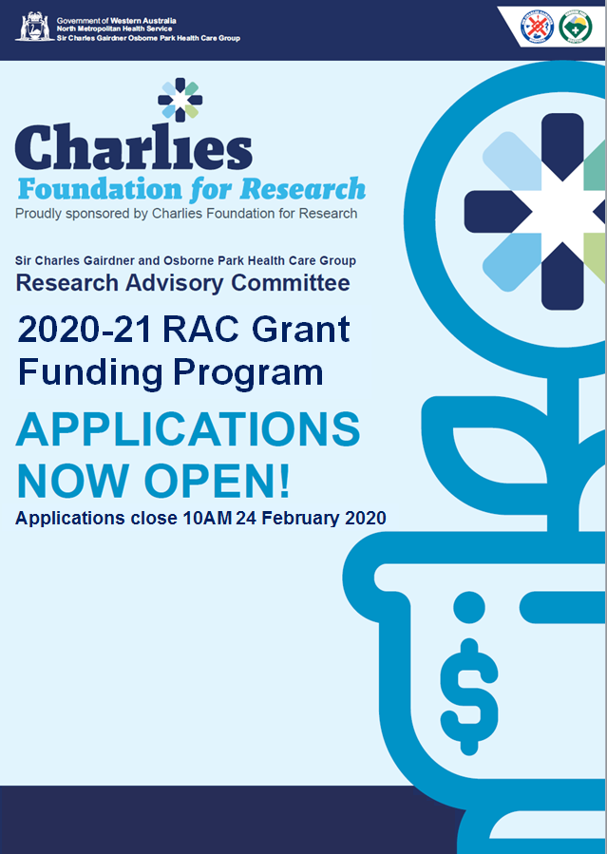
Contents
Instructions to Applicants 3
Application Form 4
Section 1: Proposed Project 4
Section 2: Research Team 5
Section 3: Ethics and Institutional Approvals 7
Section 4: Grant Reviewers 8
Section 5: Details of Project 9
Section 6: Budget 10
Section 7: Certification by Research Team 11
Section 8: Certification by Head of Department 12
Section 9: Feasibility 13
Section 10: Cited References 14
Section 11: Curriculum Vitae 15
Section 12: Checklist 16

Instructions to Applicants
The Sir Charles Gairdner Osborne Park Health Care Group (SCGOPHCG) in collaboration with the Charlies Foundation for Research are offering funding of up to $30,000 for short-term research projects to be conducted in the SCGOPHCG and completed within the 2020-21 financial year.

Applications are invited in accordance with the conditions described below.

- The allocation of all grants is subject to funding being made available.
- Available to researchers (in the role of CPI) employed within SCGOPHCG for at least 0.25 FTE.
- Researchers are only allowed to be Principal Investigators on one application.
- Late or incomplete applications will not be accepted.
- The applications must be typed in Arial font 11 point or larger.
- Do not submit the Instructions to Applicants with the Application Form.
- Acknowledgement of receipt of application will be provided via e-mail within 48 hours of the closing date.
- No hard copy submission is required.

ONE electronic submission is to be emailed to the Department of Research at SCGH.research@health.wa.gov.au in both Adobe Acrobat PDF and Microsoft Word format.

The application document name and the email subject line are to be as follows:

PI SURNAME First name – 2020-21 RAC Application
e.g. SMITH John – 2020-21 RAC Application

Queries regarding the application process should be directed via (08) 6457 4531 or SCGH.research@health.wa.gov.au.

Additional information can be found on the Department of Research intranet, including past successful RAC grant applications to assist you with the high quality expected to receive funding.

Please note the decisions of the Committee are final.

2020-21 RAC Application Form

SECTION 1: PROPOSED PROJECT
Coordinating Principal Investigator

Project title

Lay Title
This should be understandable to someone who has no knowledge of the subject matter.

Amount requested  Must not exceed $30,000 excl. gst. | $
Project summary
Summarise your research questions, methodology, and predicted benefits for the WA Health System.
Please make this understandable for a lay audience.
(Maximum 300 words)

SECTION 2: RESEARCH TEAM
- Coordinating Principal Investigator
Please note: all correspondence will be sent to this person.
Title, First Name, SURNAME
Postal address
Correspondence will be sent to this address.
Telephone number(s)
Email address
Discipline  Please tick the discipline you are from. | Medical ☐  Scientific ☐ | Nursing ☐  Allied Health ☐
Position held
CGNM Number
This will be used to check your appointment with SCGOPHCG.
% FTE employed at SCGOPHCG
SCGOPHCG Department and Location
Role in this project
What is the total amount of grant monies received in the last 5 years?

Has the CPI completed GCP training?  If no, PI must complete prior to funding being awarded.  GCP Training Links:  Global Health Training Centre  Protecting Human Research Participants  National Drug Abuse Treatment Clinical Trials Network  RET Program | ☐ Yes  ☐ No

(ii) Other Research Team Members
In addition to the Coordinating Principal Investigator listed above, please provide details (where applicable) for Principal Investigators, Associate Investigators and Research Personnel for the project. Please insert additional tables as required.

Principal Investigator 1 – will be the next point of contact after the CPI
Title, First Name, SURNAME
Position held
Institution and Location
Email address
Phone Number
Role in this project

Principal Investigator 2 – please add additional tables if required
Title, First Name, SURNAME
Position held
Institution and Location
Email address
Role in this project

Associate Investigator 1 – please add additional tables as required
Title, First Name, SURNAME
Institution
Telephone number(s)
Email address
Role in this project

Other Research Personnel, e.g. students, administration staff, lab staff
Title, First Name, SURNAME | Contribution

SECTION 3: Ethics and institutional approvals

It is the responsibility of the CPI to ensure that all appropriate approvals, guidelines and requirements are met. If the research grant is successful, evidence of ethical and institutional approvals must be provided. Please list all approvals needed and indicate progress towards achieving these.

SECTION 4: Grant reviewers
- Please provide names (if required) of reviewers that would be deemed as NOT SUITABLE for reviewing your grant application.

SECTION 5: Details of projects

(Maximum three pages)

- Hypothesis and/or Aims

- Background and Research Plan

- Significance of this research

SECTION 6: BUDGET

CPI must ensure that:
- All codes are to be provided for their budget
- Advise N/A for any section of the budget that is not relevant and in-kind may be noted

Please note: the RAC Grant does not cover the payment of GST in relation to purchases made using the grant funds.

Details
Staff  Include levels, number of staff, hours per week and on-going costs e.g. RA level 4, 0.5 FTE + Admin Staff at G3, 1 FTE etc.  Please note: Divisional finance officers are required to complete this section | Cost | Account Code
1st Quarter | $
2nd Quarter | $
3rd Quarter | $
4th Quarter | $
What is your justification for the above Staffing
Equipment  Provide full details for items over $5,000 | Cost | Account Code
1. | $
2. | $
What is your justification for the above Equipment
Animals Required  Include species and the number required. | Cost | Account Code
 | $
What is your justification for the above Animals
Maintenance Supplies  Include plastic, stationery, reagents, service contract etc. | Cost | Account Code
1. | $
2. | $
3.
What is your justification for the above Supplies
Other Costs | Cost | Account Code
1. | $
2. | $
What is your justification for the above Other Costs
Total Amount Requested for this Project (Maximum $30,000 excl. gst.) | $

The above break-down of your budget must equal the amount you have requested.

All budget items must include account codes, please refer to the Chart of Accounts (please note this is an internal link.
Finance Business Officer Full Name
Signature | Date

SECTION 7: CERTIFICATION BY RESEARCH TEAM

I confirm that:
- All information contained within this application is correct.
- That I have discussed my project in full with my Head of Department or Divisional Director and have discussed the application with heads of any other departments involved in the research.
- That this is the only application that I have submitted for Research Advisory Committee grants funding this year.

If this application is successful I undertake to ensure that this research project:
- Will meet the terms to all SCGOPHCG Research Advisory Committee Grant Guidelines and Requirements.
- Will obtain all relevant Ethical and Institutional approvals for the project:
  - HREC and institutional approvals
  - AEC
- Will be conducted as per the National Statement on Ethical Conduct in Human Research (2007) and national research standards as set out by the National Health and Medical Research Council and the Therapeutic Goods Administration.
- Will fulfill all obligations/undertakings as is required by the SCGOPHCG Research Advisory Committee.
- Will participate in any public relations as requested by the Sir Charles Gairdner Osborne Park Health Care Group to promote the grants and/or research at Sir Charles Gairdner Osborne Park Health Care Group.
- I accept that if I fail to complete my duties as a condition of receiving the grant I may be excluded from future Research Advisory Committee Grants.

Coordinating Principal Investigator
Full Name
Signature | Date

Principal Investigator 1
Full Name
Signature | Date

Principal Investigator 2
Full Name
Signature | Date

Please note: If more than two Principal Investigators, please insert additional tables as required.

SECTION 8: CERTIFICATION BY HEAD OF DEPARTMENT

If there is more than one department, please duplicate this form.

I certify that:
- The above project proposed by _____________________________ ______ (Coordinating Principal Investigator) is acceptable and appropriate to the Department and I am prepared to have the project carried out in this area;
- That this project has my full approval and support;
- That this project will have no significant impact upon my Departments Operational Budget or resources;
- I am responsible for notifying the Research Advisory Committee of any changes to the project, should anything impact upon the Coordinating Principal Investigator doing so.

Title, First Name, SURNAME
Position
Institution
Signature
Date
Telephone number(s)
Email address

SECTION 9: FEASIBILITY
- Provide a paragraph on the capacity/ability of your team and key deliverables.

Please ensure that this information is de-identified to facilitate a blind review.

SECTION 10: CITED REFERENCES
___________________________________________________________________

SECTION 11: curriculum vitae
Please attach as a SEPARATE DOCUMENT the Curriculum Vitae of the Coordinating Principal and Principal Investigators. It is requested that an abridged version only be provided, with an upper limit of two pages each, including key publications from the last 5 years.
Please note: this will NOT be sent to reviewers.
___________________________________________________________________

SECTION 12: CHECK LIST

Prior to submitting the application, the Coordinating Principal Investigator should check that they have completed the following requirements.

1. | Identified relevant approvals or agreements that are required  Note: All governance approvals (including ethics approval) must be
 | forwarded before commencement of project
2. | Attached as a separate document the CVs of the Coordinating Principal Investigator and each Principal Investigator (limited to 2 pages each)
3. | Signed the Application Form, and obtained the signature of each Principal Investigator
4. | Obtained approval and the signature for the Head of Department or Divisional Director
5. | Removed the INSTRUCTIONS page from the APPLICATION FORM for electronic submission
6. | Emailed the completed application form in both Adobe Acrobat PDF and Microsoft Word format to SCGH.research@health.wa.gov.au.

