DUAL BONE SCAN
Patient Information Sheet – Total Procedure Time: 2 days

Your Appointment
You can write the details of your appointment here:

DATE: _______________

TIME: _______________
Please call us and tell us your weight before your appointment

Pregnant?
Please tell us if there is a chance you may be pregnant
Please tell us if you are pregnant or breastfeeding

Contact Us
Phone: 6457 2322
Open: Mon-Fri 7:00am-5:00pm.
Sir Charles Gairdner Hospital Nuclear Medicine Department First Floor – Blue Lifts – G Block

Scan Procedure
A dual bone scan is an imaging procedure used to evaluate infection. The test is performed over 2 days.

Day One Time: 2.5 hours
Part one of the procedure takes about two hours. We will take some of your blood and label it with a radioisotope. The labelling process takes approximately two hours. During this time we will also give you an injection of a radioactive tracer that goes to your bones and take some pictures. At the end of the blood label we will give you an injection of your labelled blood.

Day Two Time: 2 hours
Part two of the test takes place on day two and can take about two hours. We will take pictures of the site of infection. You will be required to keep still while we take the pictures.

Preparation

To come prepared for your scan please:
- Do not wear jewellery to your appointment.
- Do not wear clothes that have metal on them. This includes zippers, buttons and embellishments.
- Bring copies of previous scans with you.
- Drink extra fluid on both days of your scan.

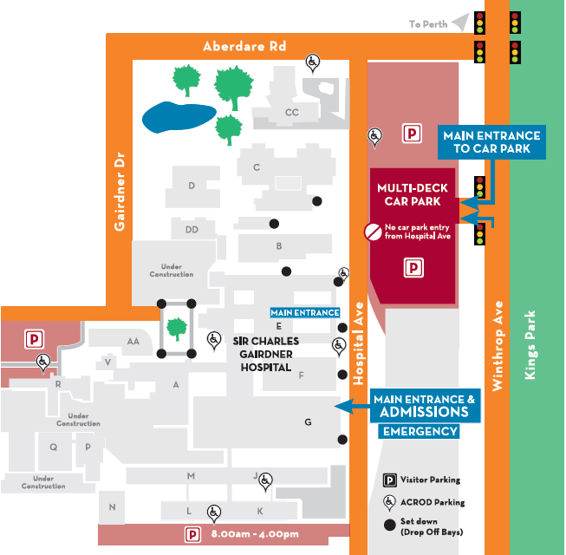
Where To Find Us:
We Are Here:
1st Floor
Blue Lifts
G Block

Sir Charles Gairdner Hospital

Nuclear Medicine Department

First Floor- Blue Lifts – G Block

