Heart – Ejection Fraction
Patient Information Sheet – Total Procedure Time: 2 hours

Your Appointment
You can write the details of your appointment here:

DATE: _______________

TIME: _______________

Pregnant?
Please tell us if there is a chance you may be pregnant
Please tell us if you are pregnant or breastfeeding

Contact Us
Phone: 6457 2322
Open: Mon-Fri 7:00am-5:00pm.
Sir Charles Gairdner Hospital Nuclear Medicine Department First Floor – Blue Lifts – G Block

Scan Procedure
This scan looks at how well your heart is functioning. We can calculate how well your heart is pumping. This scan is often performed before and during chemotherapy to make sure the heart is performing well. It may also be to check up on the heart during or following these procedures.

Part One – Injection Time: 15 minutes
You will be given an injection of a radioactive tracer. You will be asked to eat following this injection to allow the tracer to move away from the stomach and bowel.

Part Two – Scan Time: 30 minutes
We will image your heart at least an hour after the injection. The images take approximately 30 minutes.

Preparation

To come prepared for your scan please:
- Do not wear jewellery to your appointment.
- Do not wear clothes that have metal on them. This includes zippers, buttons and embellishments.
- Bring copies of previous scans with you.
- Drink extra fluid on the day of your scan.

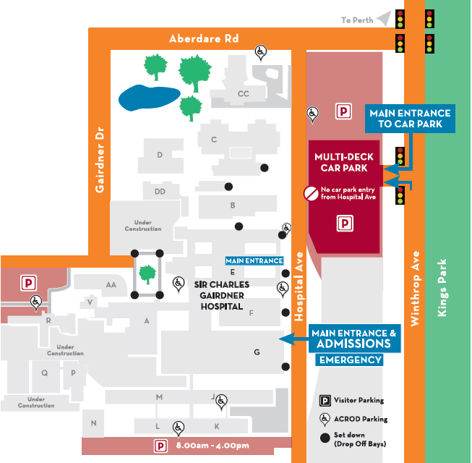
Where To Find Us:
We Are Here:
1st Floor
Blue Lifts
G Block

Sir Charles Gairdner Hospital

Nuclear Medicine Department

First Floor- Blue Lifts – G Block

