Hepatobiliary (Gallbladder)
Patient Information Sheet – Total Procedure Time: 3 hours

Your Appointment
You can write the details of your appointment here:

DATE: _______________

TIME: _______________

Pregnant?
Please tell us if there is a chance you may be pregnant
Please tell us if you are pregnant or breastfeeding

Contact Us
Phone: 6457 2322
Open: Mon-Fri 7:00am-5:00pm.
Sir Charles Gairdner Hospital Nuclear Medicine Department First Floor – Blue Lifts – G Block

Scan Procedure
This scan looks at the function of the gallbladder and the bile system. The procedure takes approximately 3 hours.

Scan Time: 3 hours
You will be given an injection of a radioactive tracer that goes to the gallbladder. We will then take pictures of the gall bladder for one hour.
Following this scan we may give you a drink or an injection and then continue scanning for another 30 to 60 minutes. During the scan you will be required to keep still.

Preparation

To come prepared for your scan please:
- Fast for at least 4 hours prior to the appointment.
- Cease narcotic medications 4 hours prior to the appointment. If you are unsure about whether your medications contain narcotics please phone us.
- Do not wear jewellery to your appointment.
- Do not wear clothes that have metal on them. This includes zippers, buttons and embellishments.
- Bring copies of previous scans with you.

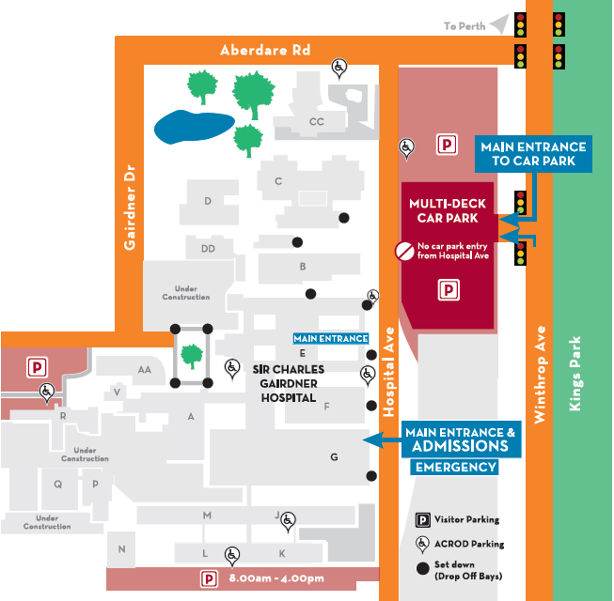
Where To Find Us:
We Are Here:
1st Floor
Blue Lifts
G Block

Sir Charles Gairdner Hospital

Nuclear Medicine Department

First Floor- Blue Lifts – G Block

