Lung Shunt Scan
Patient Information Sheet – Total Procedure Time: 1 hour 30 min

Your Appointment
You can write the details of your appointment here:

DATE: _______________

TIME: _______________

Pregnant?
Please tell us if there is a chance you may be pregnant
Please tell us if you are pregnant or breastfeeding

Contact Us
Phone: 6457 2322
Open: Mon-Fri 7:00am-5:00pm.
Sir Charles Gairdner Hospital Nuclear Medicine Department First Floor – Blue Lifts – G Block

Scan Procedure
A lung shunt scan demonstrates the presence of an arteriovenous right to left shunt. We can also determine the size of the shunt.

Part One – Injection Time 30 minutes
We will insert a canula into a vein in your arm. We will then ask you to stand for 10 minutes, after which time we will give you an injection of a radioactive tracer whilst you are still standing.

Part Two – Scan Time: 1 hour
Following the injection we will take some images. We will take pictures for approximately 1 hour. You will be required to lie still during the pictures.

Preparation

To come prepared for your scan please:
- Do not wear jewellery to your appointment.
- Do not wear clothes that have metal on them. This includes zippers, buttons and embellishments.
- Bring copies of previous scans with you.

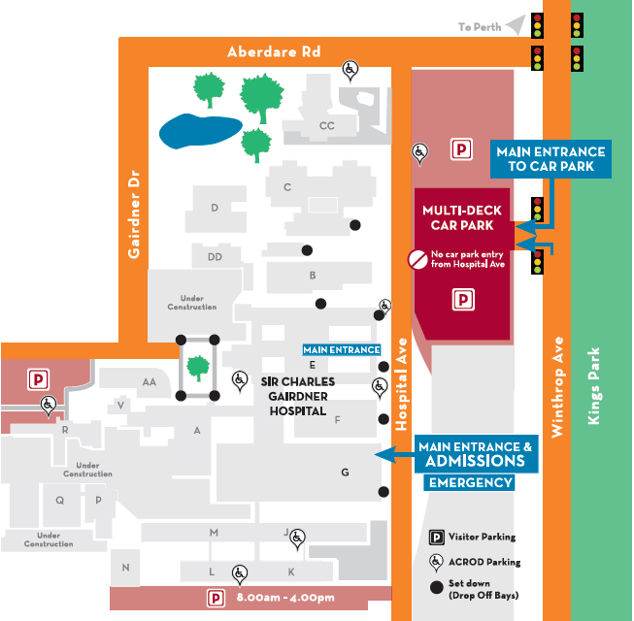
Where To Find Us:
We Are Here:
1st Floor
Blue Lifts
G Block

Sir Charles Gairdner Hospital

Nuclear Medicine Department

First Floor- Blue Lifts – G Block

