Lung V/Q Scan
Patient Information Sheet – Total Procedure Time: 1 hour

Your Appointment
You can write the details of your appointment here:

DATE: _______________

TIME: _______________

Pregnant?
Please tell us if there is a chance you may be pregnant
Please tell us if you are pregnant or breastfeeding

Contact Us
Phone: 6457 2322
Open: Mon-Fri 7:00am-5:00pm.
Sir Charles Gairdner Hospital Nuclear Medicine Department First Floor – Blue Lifts – G Block

Scan Procedure
A V/Q scan, also known as a lung scan, looks at the air supply and the blood supply to the lungs. It can evaluate the presence of pulmonary embolism. V/Q stands for ventilation/perfusion. The entire procedure takes approximately one hour.

Part One – Ventilation Time: 30 minutes
For the ventilation scan you will be asked to breathe in a radioactive tracer. This tracer will show us whether or not your airways are clear. We will take pictures for approximately 20 minutes. You will be required to keep still and breathe normally.

Part Two – Perfusion Time 30 minutes
As soon as we finish the ventilation scan we will start the perfusion scan. For the perfusion scan you will be given an injection of a radioactive tracer. This tracer will go to your lungs and show us whether or not your blood vessels are blocked. We will take pictures for approximately 10 minutes. You will be required to keep still and breathe normally.

Preparation

To come prepared for your scan please:
- Do not wear jewellery to your appointment.
- Do not wear clothes that have metal on them. This includes zippers, buttons and embellishments.
- Bring copies of previous scans with you.

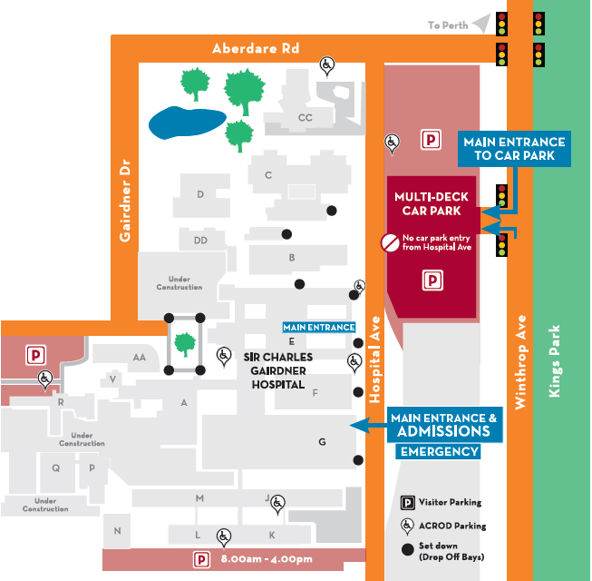
Where To Find Us:
We Are Here:
1st Floor
Blue Lifts
G Block

Sir Charles Gairdner Hospital

Nuclear Medicine Department

First Floor- Blue Lifts – G Block

