MIBG Cardiac Scan
Patient Information Sheet – Total Procedure Time: 6 hours

Your Appointment
You can write the details of your appointment here:

DATE: _______________

TIME: _______________

Pregnant?
Please tell us if there is a chance you may be pregnant
Please tell us if you are pregnant or breastfeeding

Contact Us
Phone: 6457 2322
Open: Mon-Fri 7:00am-5:00pm.
Sir Charles Gairdner Hospital Nuclear Medicine Department First Floor – Blue Lifts – G Block

Scan Procedure
This scan helps to diagnose Parkinson’s disease. The scan will image the nerves in the heart using a tracer called MIBG. There are three parts to this appointment.

Part One Time: 15 minutes
The first part of this test involves taking a few drops of Lugol’s solution with a cup of water. This will stop your thyroid gland from absorbing any iodine from this study. You will be asked to wait an hour for part two of the test.

Part Two Time: 30 minutes
You will be given an injection of a radioactive tracer. A scan of your heart will be taken shortly after this. This scan will take approximately 30 minutes. You may leave the department between part one, part two and part three of the study.

Part Three Time: 30 minutes
We need to do another scan of your heart about 3-4 hours after the first scan. This scan will also take approximately 30 minutes.

Preparation

To come prepared for your scan please:
- Do not wear jewellery to your appointment.
- Do not wear clothes that have metal on them. This includes zippers, buttons and embellishments.
- Bring copies of previous scans with you.

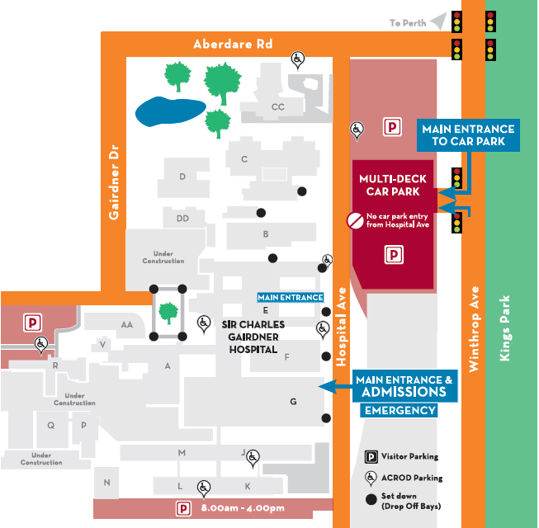
Where To Find Us:
We Are Here:
1st Floor
Blue Lifts
G Block

Sir Charles Gairdner Hospital

Nuclear Medicine Department

First Floor- Blue Lifts – G Block

