Myocardial Perfusion Scan
Patient Information Sheet – Total Procedure Time: 2 days

Your Appointment
You can write the details of your appointment here:

DATE: _______________

TIME: _______________

Pregnant?
Please tell us if there is a chance you may be pregnant
Please tell us if you are pregnant or breastfeeding

Contact Us
Phone: 6457 2322
Open: Mon-Fri 7:00am-5:00pm.
Sir Charles Gairdner Hospital Nuclear Medicine Department First Floor – Blue Lifts – G Block

Scan Procedure
A myocardial perfusion scan is a two day appointment to look at the blood supply to your heart. We can also see how well the heart is pumping.

Day 1: Rest Test Time: 2 hours
This test will take about two hours. You will be given an injection of a radioactive tracer. You will be asked to eat following this injection. We will image your heart at least an hour after the injection.

Day 2: Stress Test Time: 3 hours
This test will take about three hours. A nurse and a doctor will perform your stress test. The stress test may be performed with you exercising on a treadmill or you may be given a drug as an alternative. During the stress test you will be given an injection of a radioactive tracer. You will be given food and drink when the stress test is finished. We will image your heart at least an hour after the stress test.

Preparation
To come prepared for your scan please:
- Do not smoke, eat or drink for 4 hours before the Day 2 stress test
- Do not have any caffeine for 24 hours before the Day 2 stress test. Caffeine Includes: Tea, coffee, Milo, chocolate, soft drinks and some medicines.
- Do not wear jewellery to your appointment.
- Do not wear clothes that have metal on them. This includes zippers, buttons and embellishments.
- Bring a list of all of your current medications with you.
- Bring copies of previous scans with you.

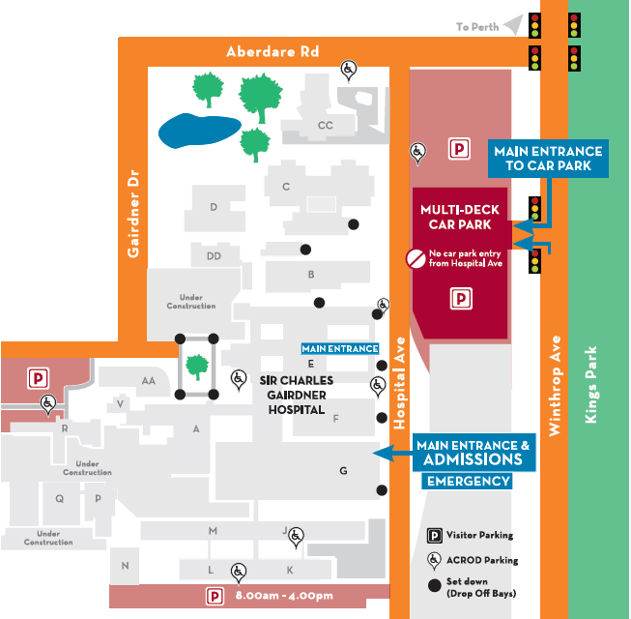
Where To Find Us:
We Are Here:
1st Floor
Blue Lifts
G Block

Sir Charles Gairdner Hospital

Nuclear Medicine Department

First Floor- Blue Lifts – G Block

