Parathyroid scan
Patient Information Sheet – Total Procedure Time: 6 hours

Your Appointment
You can write the details of your appointment here:

DATE: _______________

TIME: _______________

Pregnant?
Please tell us if there is a chance you may be pregnant
Please tell us if you are pregnant or breastfeeding

Contact Us
Phone: 6457 2322
Open: Mon-Fri 7:00am-5:00pm.
Sir Charles Gairdner Hospital Nuclear Medicine Department First Floor – Blue Lifts – G Block

Scan Procedure
This scan looks at the parathyroid glands. The scan is used to assess hyperparathyroidism and look for adenomas.

Part One - Drink Time: 15 minutes
This will take about 15 minutes. You will be given a drink of iodine. You will then have a 3 hour break before part two. You may leave the department during this time.

Part Two - Scan Time: 1 hour
This will take about one hour. You will be given an injection of a radioactive tracer. We will also take pictures.

Part Three - Scan Time: 20 minutes
Sometimes we may need you to return for a delayed scan. This scan is 2 hours after part two and will take about 20 minutes.

IMPORTANT!
If, in the 6 weeks leading up to your scan, you have had:
- Contrast media (e.g. from a CT scan, angiogram or IVP).
- Foods containing high amounts of iodine.
- Medications/vitamins containing iodine.
- Medication for your thyroid
PLEASE CALL US IMMEDIATELY

Preparation

To come prepared for your scan please:
- Do not wear jewellery to your appointment.
- Do not wear clothes that have metal on them. This includes zippers, buttons and embellishments.
- Bring copies of previous scans with you.

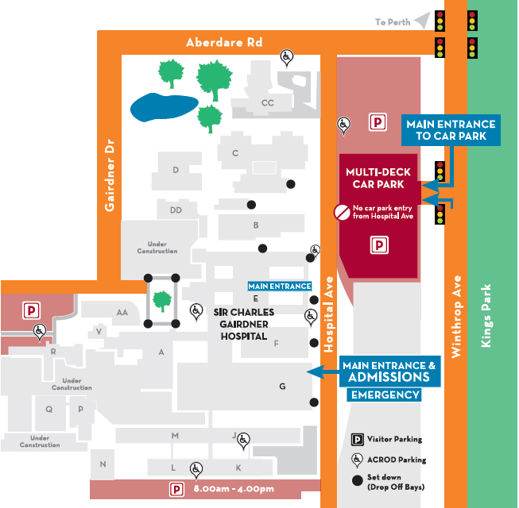
Where To Find Us:
We Are Here:
1st Floor
Blue Lifts
G Block

Sir Charles Gairdner Hospital

Nuclear Medicine Department

First Floor- Blue Lifts – G Block

