Thyroid Scan
Patient Information Sheet – Total Procedure Time: 1 Hour

Your Appointment
You can write the details of your appointment here:

DATE: _______________

TIME: _______________

Pregnant?
Please tell us if there is a chance you may be pregnant
Please tell us if you are pregnant or breastfeeding

Contact Us
Phone: 6457 2322
Open: Mon-Fri 7:00am-5:00pm.
Sir Charles Gairdner Hospital Nuclear Medicine Department First Floor – Blue Lifts – G Block

Scan Procedure
This scan evaluates the function of the thyroid. This scan may be evaluating an overactive or an underactive thyroid gland.

Scan Time: 1 hour
This test will take about one hour. You will be given an injection of a radioactive tracer. We will wait twenty minutes before we start the scan. You will be asked to drink a cup of water just before the scan starts.
After the scan you will be asked to wait so that one of our doctors can come and talk to you.

IMPORTANT!
If, in the 6 weeks leading up to your scan, you have had:
- Contrast media (from a CT scan, angiogram or IVP).
- Foods containing high amounts of iodine.
- Medications/vitamins containing iodine.
- Medication for your thyroid

PLEASE CALL US IMMEDIATELY

Preparation

To come prepared for your scan please:
- Do not wear jewellery to your appointment.
- Do not wear clothes that have metal on them. This includes zippers, buttons and embellishments.
- Bring copies of previous scans with you.

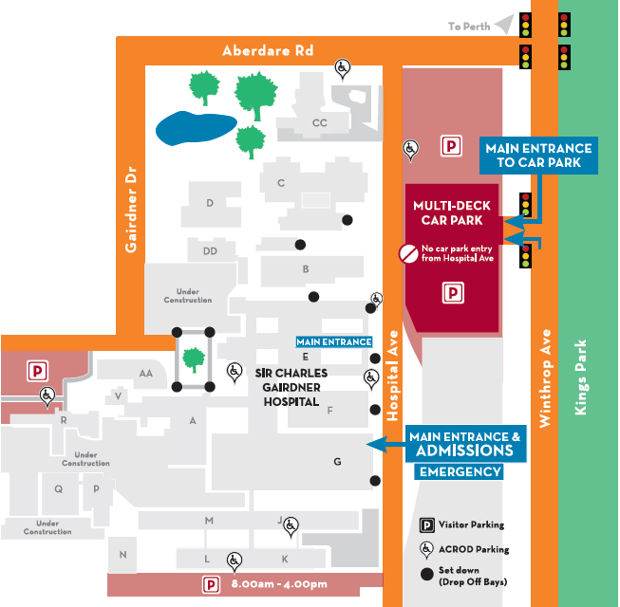
Where To Find Us:
We Are Here:
1st Floor
Blue Lifts
G Block

Sir Charles Gairdner Hospital

Nuclear Medicine Department

First Floor- Blue Lifts – G Block

